**Admin can update or delete any user**

At the moment, an Admin can't update or delete other user or their post. Lets make some change so that admin can update or delete any user or post. Lets begin by working on users.

**user/Profile.js**

* All we need to do is show the edit and delete buttons to admin user when the admin visits any user's profile page
* Then the rest will be handled by our backend, If same user or admin is sending request. it will succeed or else the error will be thrown.
* However we don't want to touch the existing edit/delete buttons that are already there for users.
* We will create separate buttons so that they look different and identical for the admin.

**user/Profile.js**

Put this code right after the existing buttons inside render(). These buttons will be visible only to admin.

<div>

{isAuthenticated().user &&

isAuthenticated().user.role === "admin" && (

<div class="card mt-5">

<div className="card-body">

<h5 className="card-title">

Admin

</h5>

<p className="mb-2 text-danger">

Edit/Delete as an Admin

</p>

<Link

className="btn btn-raised btn-success mr-5"

to={`/user/edit/${user._id}`}

>

Edit Profile

</Link>

<DeleteUser userId={user._id} />

</div>

</div>

)}

</div>

Now Admin can update or delete any user's profile.

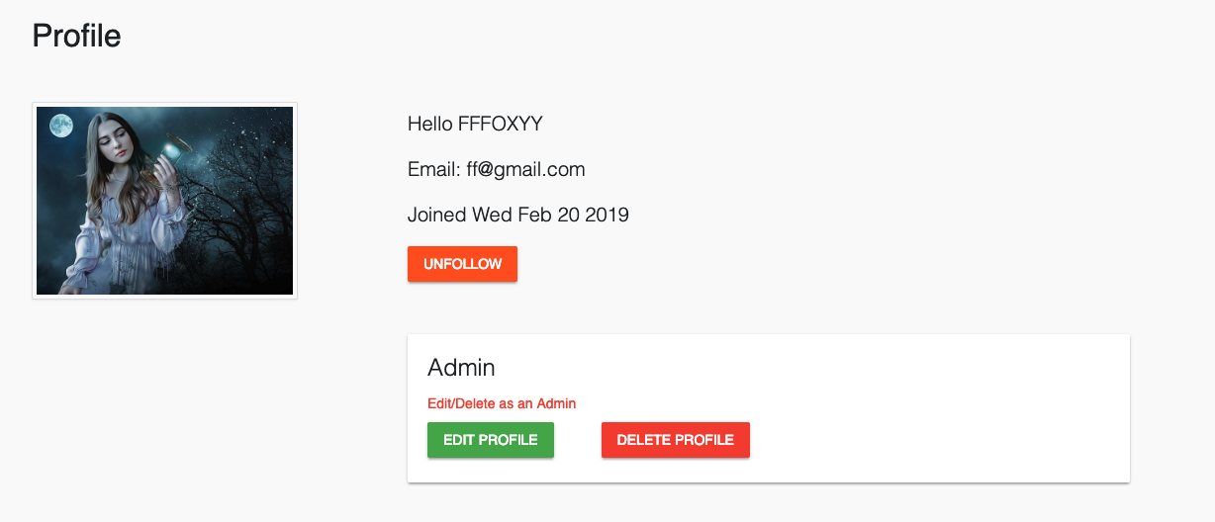

**Currently any user can land on admin page.**

Lets make sure only admin user can land on this page.  Add redirectToHome property to state with default value of false then on componentDidMount() set the value to true.

Then inside render() if redirectToHome value is true, redirect to home page.

**admin/Admin.js**

// first import isAuthenticated and Redirect

import { isAuthenticated } from "../auth";

import { Redirect } from "react-router-dom";

// then inside class Admin create state

state = {

redirectToHome: false

};

// then on componentDidMount()

componentDidMount() {

if (isAuthenticated().user.role !== "admin") {

this.setState({ redirectToHome: true });

}

}

// then inside render()

render() {

if (this.state.redirectToHome) {

return <Redirect to="/" />;

}

// rest of the existing code

// ...

}

OK. We have implemented admin capabilities in users. Let's do the same with posts so that admin can update or delete any post. That's in the next lecture.